1. Call Out form, “Call Out by”, Dropdown list should show effective employees only order by first name alphabetically. Default to the login user in next step development when we have user identity by security control.——BUG058 Fixed by Bright 1130

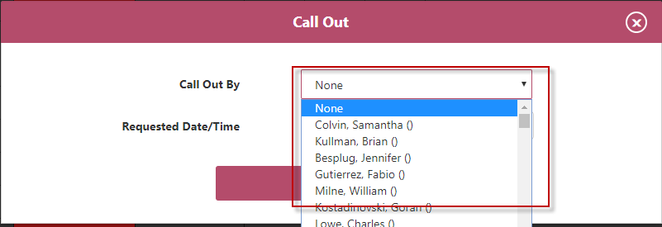

1. “Add New Rig” form, “Rig Contractor” dropdown list should list effective drilling companies only. Not energy companies. – Fixed by Adam

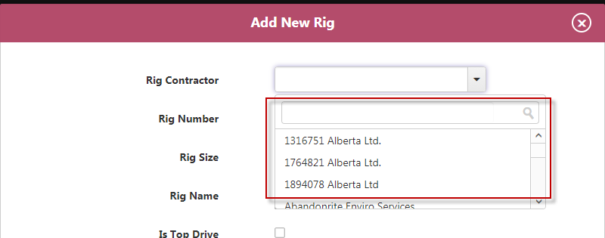

1. When playing with “need bin” function, job status went from “Complete” to “Confirmed”.    Adding a bin should not change rig status.  In addition, the call sheet status for the job was Ready, which should = “Scheduled” on the rig board, not “confirmed.” ——BUG070 Fixed 1205
2. Bin on/off location times are not needed in the add bin function.  ——BUG063 Bright Fixed 1130
3. When a 2nd bin or consultant is added it doubles the size of the row, making it a bit too big.  Is there a way we can shrink the rows when they go to 2 tows to try to keep it smaller? ——BUG071 未修改
4. Change “Consultant” to “OSR” in column heading. BUG064 Bright BUG064 Bright Fixed 1130